**Technology**

**Sensors**

**Photo-resistor:** this component has a resistivity that varies depending on the amount of light that it perceives. When in the dark the resistance of this sensor gets quiet high. Our own sensor used in this project have values from 1KΩ under the light up to 10KΩ in the dark. It is made using a material. It works in a way that when photons come in contact with the top part of the sensor, electrons start travelling through the electrodes. Because this sensor only have resistance as output and Arduino takes voltage input, we use the voltage divider rule to connect it to our board. They can used in devices like alarm clock and streetlight.[1]

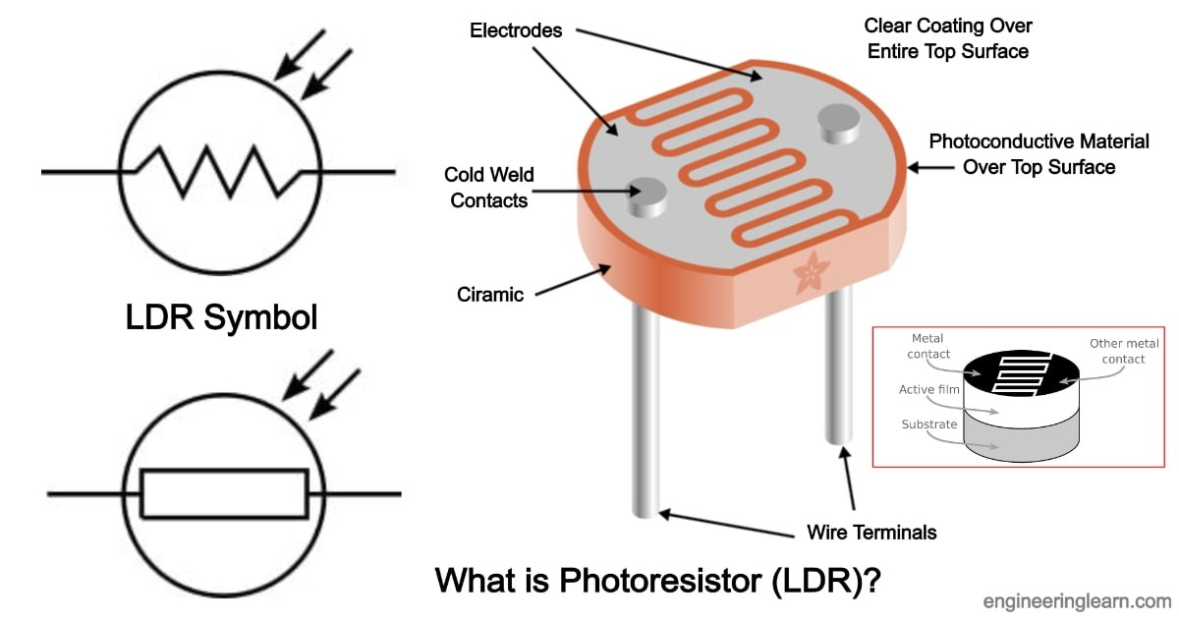

**Temperature/Humidity sensor:** There is a build in NTC Thermistor and capacitive sensor for respectively temperature and humidity measurement .it has a measuring range of 0 to 50°C for temperature and 20 to 90% RH. This sensor has a digital output [2].

Ein Bild, das Text, Elektronik enthält.

Water level sensor: It has 10 parallel conductors that act like a potentiometer with resistance changes based on the level of water. The higher is the level of water, the lower is the resistance. Based on the value of the resistance a certain output voltage is sent. It can be used to check leakage of water, rainfall, or maybe if a tank is overflowing [4].

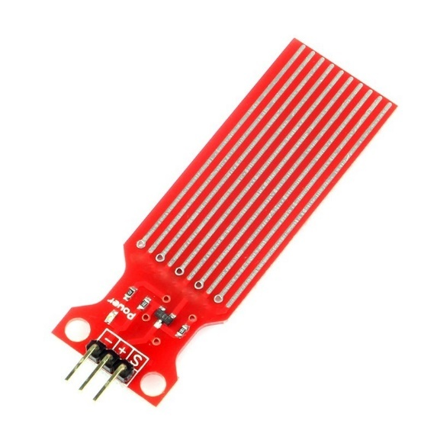

**Actuators**

LED: is used in this situation to showcase a situation whereby when it gets dark then the light turns ON automatically

Resistors: we used one 220-ohm (use to limit the amount of current flowing) resistor for the LED and one 10K -ohm for the photo-resistor

Servomotor (SG90): It can turn up to 90 degrees in both directions. The controlling of the position happens via PWM (pulse width modulation) with a frequency of 50Hz and period of 20ms.It can be used in situation where position control is required. The main components of a servomotor are potentiometer, gearbox, DC motor and a control circuit [5].

Ein Bild, das Tisch enthält.
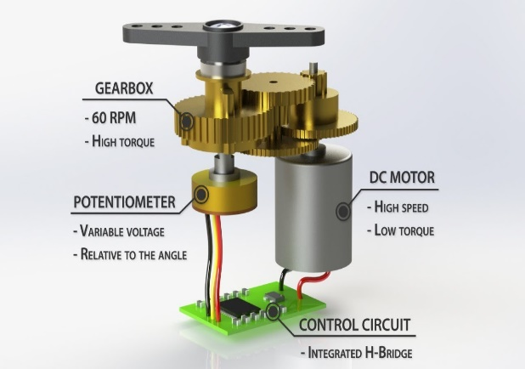

**Communication Protocols**

**MQTT:** message queuing telemetry transport is a lightweightpublisher/subscriber messaging protocol designed for machine-to-machine telemetry in low bandwidth environments. It is design for the internet of things. Some of its advantages are quick to implement, fast and efficient message delivery, reduction in network bandwidth usage. Some of the issues that it faces are related to safety [3]

**WI-FI:** It is a protocol that makes it possible for devices like cell phones and many other devices to connect and exchange information via order with internet. This is done through a wireless router

**Software**

Arduino IDE: was used to write the code for sensors and actuator

Command line in Raspberry Terminal was used for MQTT

Raspbian: operating system for the raspberry

VNC: was used during the set-up of the Raspberry

**Programming Languages**

C-language was used on the Arduino side to write the code for all sensors and the stepper motor

**Controller Units**

**Arduino Uno Wi-Fi(R2)**

This component is WIFI capable. It acts as sensor node to collect all data from all our sensors and send it via WIFI to the host which is the Raspberry. It also drives our output which is the servo motor

**Raspberry Pi 3 Model B**

Is the host computer and must communicate with the Arduino to collect the data and store it. The data is then published to the web server via MQTT protocol

**References:**

[1 ] [How to Use a Photoresistor - Arduino Project Hub](https://create.arduino.cc/projecthub/MisterBotBreak/how-to-use-a-photoresistor-46c5eb)

[2] [In-Depth: Interface DHT11 Module With Arduino (lastminuteengineers.com)](https://lastminuteengineers.com/dht11-module-arduino-tutorial/)

[3] <https://mqtt.org/>

[4 ][In-Depth: How Water Level Sensor Works and Interface it with Arduino - Last Minute Engineers](https://lastminuteengineers.com/water-level-sensor-arduino-tutorial/)

[5] [How to Control Servo Motors with Arduino - Complete Guide (howtomechatronics.com)](https://howtomechatronics.com/how-it-works/how-servo-motors-work-how-to-control-servos-using-arduino/)